What is Web 3.0 and its impact?
Are you ready to experience the new and advanced era of the internet? Web 3.0- The ultimate tech-driven third generation of web technology. This tiny word has created a lot of buzz in the market. The internet has blurred the line between reality and virtual space. And the current iteration of the internet is still witnessing many advancements with each passing day. This next version of the internet is expected to be more sophisticated and intelligent than the current one. It leverages machine learning, artificial intelligence, and blockchain, to attain real-world human communication. An interesting fact about this new generation of web is that it not only allows individuals to own their data but they will be compensated for their time spent on the web. Three words that define Web 3.0 are decentralization, openness, and incredible user utility.
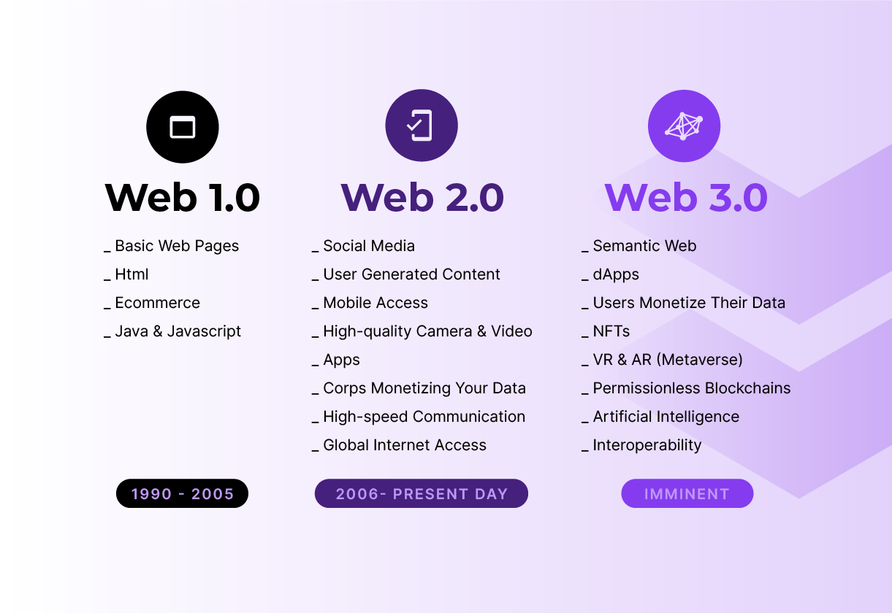

Welcome To The Future Of The Internet- WEB 3.0!
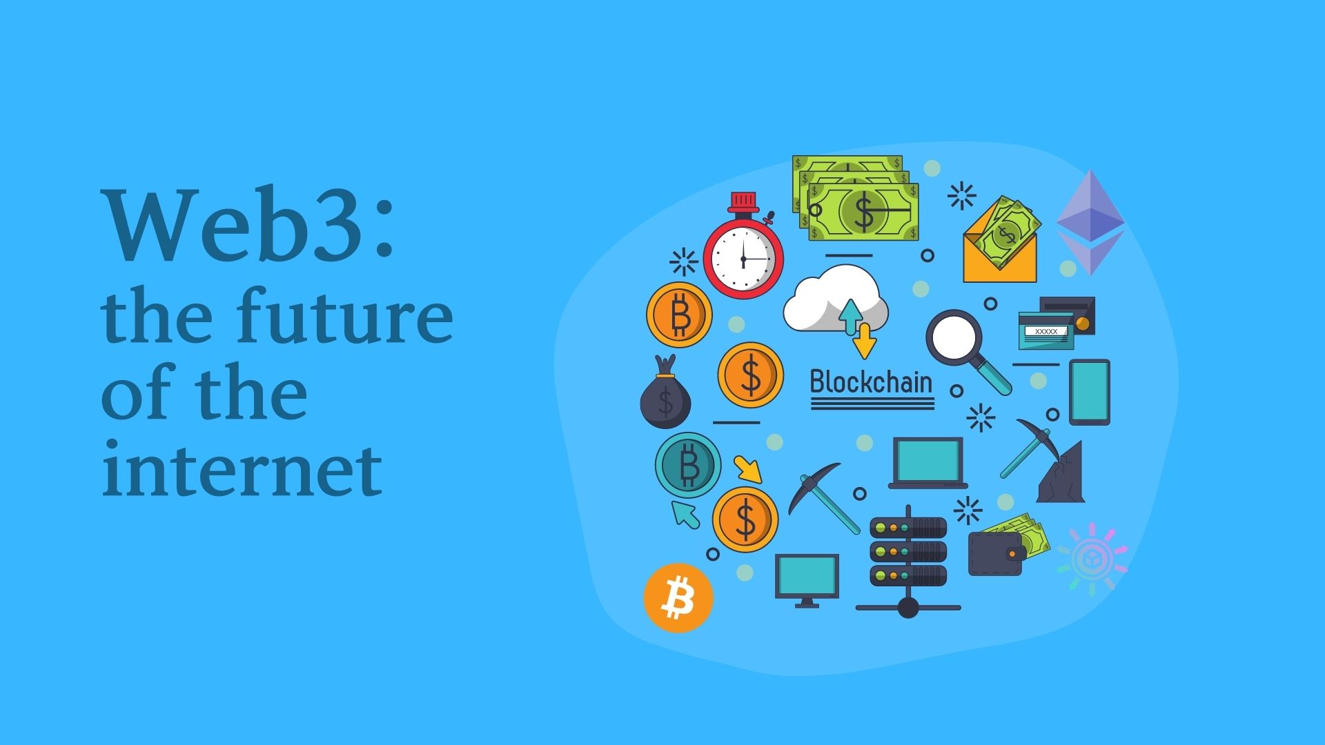

The current version of the web is characterized by social media platforms, which permit greater proliferation of user-generated content. At present, five major companies hold control of our data usage and storage. These companies include Twitter, Meta, Google, Apple, and Microsoft. Their algorithms decide upon the information that we consume. Whereas Web 3.0 with its crypto, blockchain, and metaverse use cases is being touted as a movement that will wrest back the control of the internet from these big tech companies.

How Will Web 3.0 Affect Search Marketing?
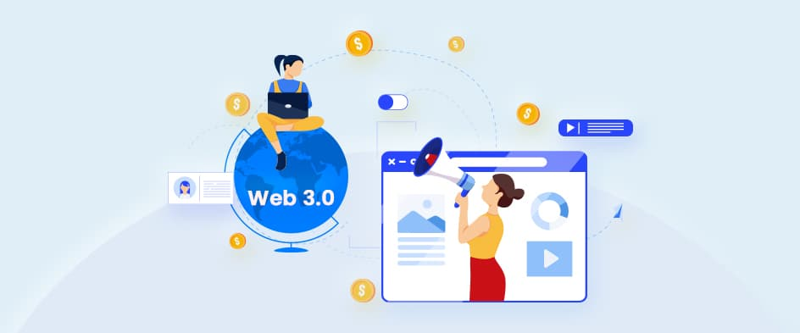

Well, talking about the marketing aspect, Web 3.0 is expected to provide a far more personalized browsing experience, and rich as well as interactive advertising opportunities. Natural language processing technology is expected to enable computers to better understand the response to the data provided by humans. In the coming years, a thorough understanding of the keywords, search engines, markup, and semantics will play a bigger role. And understanding the interconnectedness of data will derive absolute benefits from search engine optimization.

Will Web 3.0 Bring A Change?
The Internet has gone through countless changes since its birth, but this major change is here to stay. From being limited to a fixed number of computers to being a ubiquitous virtual entity, the evolution of the internet is drastic. And web 3.0 is one of the biggest achievements promising unmatched experience and changing the way we interact with the web. The coming generation of the internet will be fundamentally open or transparent, thrustless, and decentralized.
What do you think will be the impact of Web 3.0 on the digital era? Will this be easy to implement? If you are an entrepreneur, then you should keep an eye on its progress to capitalize on any opportunities as Web 2.0 phases out and Web 3.0 becomes the new normal. Get ready for Web 3.0 with Baniwal Infotech and make your business compatible with this new generation of the internet. For more information, visit our website https://baniwalinfotech.com/ or for any queries shoot us a mail at info@baniwalinfotech.com. Let us together leverage the power of Web 3.0 and hop on to the bandwagon.

